Introduction
The firmware installed on the device defines a fixed format for themes and subscription message formats. Default connection to the tms and emxq mqtt servers of dspread.
You can use any MQTT testing tool to connect to the DSPREAD MQTT server.

Demonstration broadcast
Taking MQTTX tool as an example, explain the connection method.
- Config Param
MqttServer: mqtts:// q123b328.ala.cn-hangzhou.emqxsl.cn
ServerPort: 8883
Client ID: your device sn
UerName:123456
Password:123456
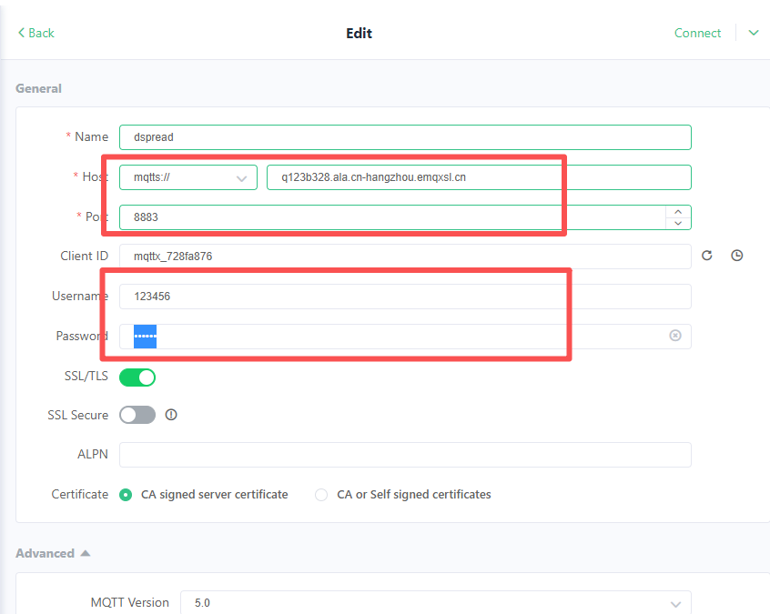

- Topic and Message Format
Topic: user/message/TDS10SEU000030
Please note that TDS10SEU000030 is the device serial number, you need to modify it to your device serial number
Message Format:
{ "status": "success","orderId":"12345677","amount":1234.56 }
Please note that orderId cannot be duplicated
